**Assignment -string and string operations**

1. **Write a C program to count the number of vowels in a string.**

Code:

#include<stdio.h>

int main()

{

char str[100];

int i,count=0;

printf("Enter the string value here:");

scanf("%s",str);

while(i!='\n')

{

if(str[i]=='a' || str[i] =='e' || str[i] == 'i' || str[i] == 'o' || str[i]== 'u')

{

count = count +1;

}

if(str[i]=='A' || str[i] =='E' || str[i] == 'I' || str[i] == 'O' || str[i]== 'U')

{

count = count +1;

}

i++;

}

printf("No. of vowels is %d",count);

}

**Output:**

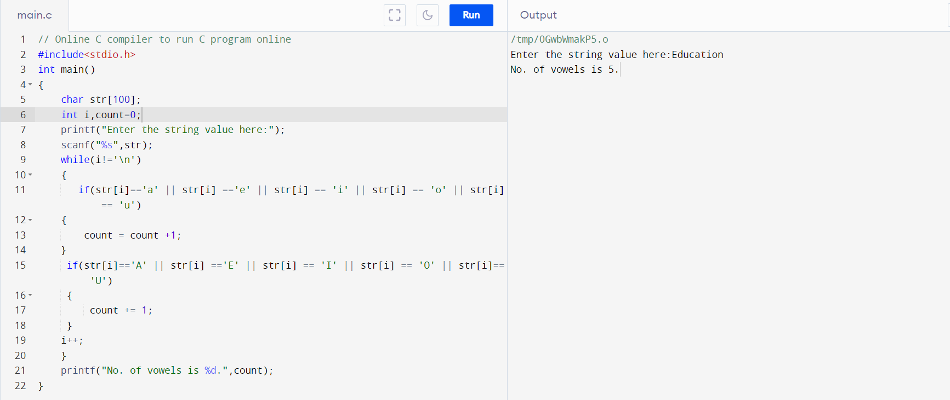

2.**Write a program in C to find the length of a string without using library function**

Code:

#include<stdio.h>

int main()

{

char str[200];

int i,count=0;

printf("Enter the string here:");

scanf("%s",str);

//checking the number of characters;

//it counts only those characters which have no spcace between them

for(i=0;str[i]!='\0';i++)

{

count = count +1;

}

printf("Length of the string is %d.",count);

}

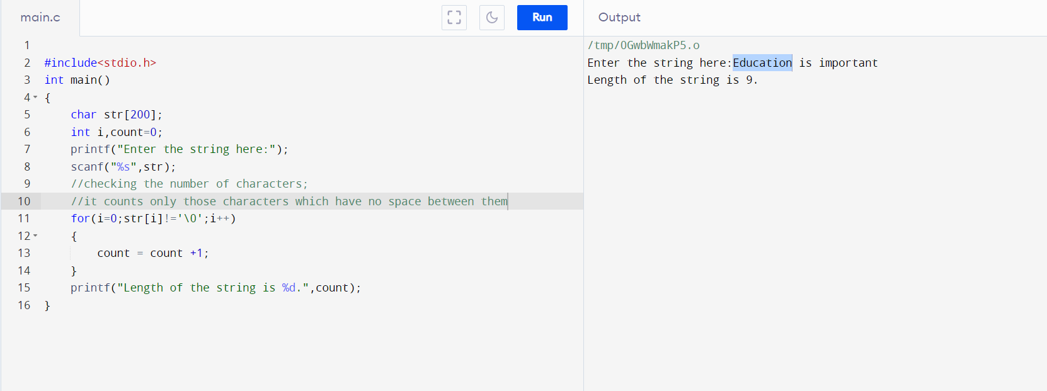**Output:**

**3.Write a program in C to print individual characters of string in reverse order.**

Code:

//Write a program in C to print the string in reverse order.

#include<stdio.h>

#include<string.h>

int main()

{

int i=0,l;

char str[1000];

printf("Enter the string: ");

scanf("%s",str);

//int i=0;

l=strlen(str);

printf("The string in reverse order is :");

for(i=l;i>=0;i--)

{

printf("%c ",str[i]);

}

}

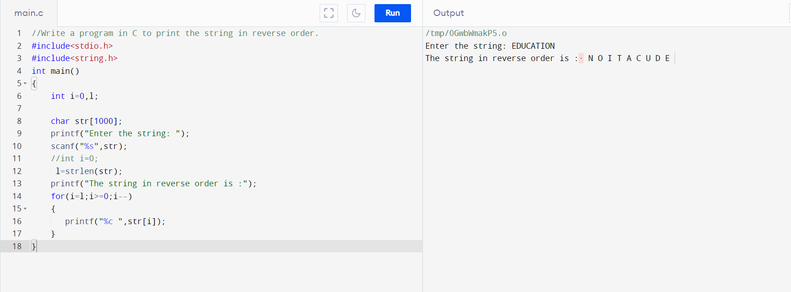**Output:**

**4.Write a program in C to compare two strings without using library functions.**

Code:

// C proram for comparing two strings

#include<stdio.h>

#include<string.h>

int main()

{

char str1[100],str2[100];

int L1,L2,i,count=0;

printf("Enter two string to compare:\n");

printf("First string: ");

scanf("%s",str1);

printf("Second string: ");

scanf("%s",str2);

L1=strlen(str1);

L2=strlen(str2);

if(L1==L2)

{

printf("The strings have same length.\n");

for(i=0;i<L1;i++)

{

if (str1[i]==str2[i])

{

count++;

}

}

if (count==L1)

{

printf("The strings have same characters\n");

}

}

else

{

printf("the strings are different. ");

}

}

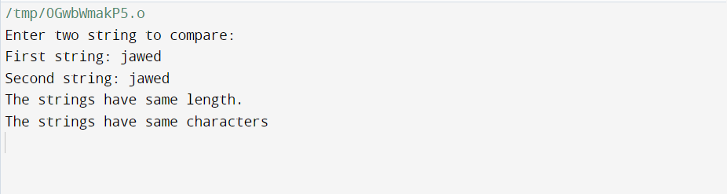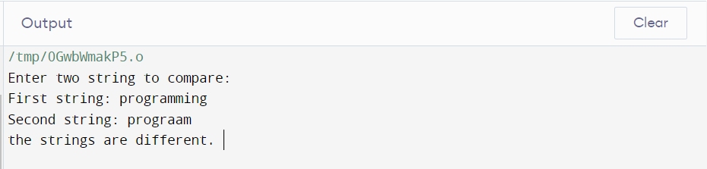**Output:**

**5.Write a program in C to count total number of alphabets, digits and special characters in a string.**

Code:

#include <stdio.h>

#include <string.h>

#include <stdlib.h>

void main()

{

char str[500];

int alp=0, digit=0, ch=0, i=0;

//alp = digit = splch = i = 0;

printf("Input the string : ");

fgets(str, sizeof str, stdin);

while(str[i]!='\0')

{

if((str[i]>='a' && str[i]<='z') || (str[i]>='A' && str[i]<='Z'))

{

alp++;

}

else if(str[i]>='0' && str[i]<='9')

{

digit++;

}

else

{

ch++;

}

i++;

}

printf("Number of Alphabets in the string is : %d\n", alp);

printf("Number of Digits in the string is : %d\n", digit);

printf("Number of Special characters in the string is : %d\n\n", ch);

}

Output:

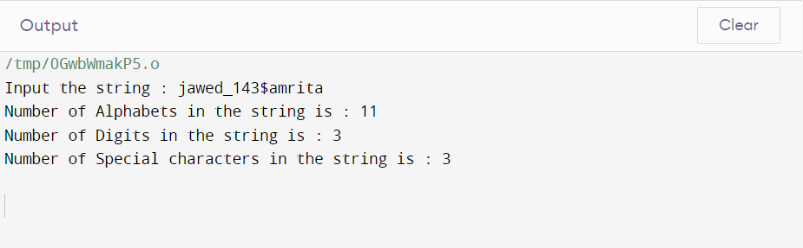

**6.Write a program in C to copy one string to another string.**

Code:

#include <stdio.h>

#include <string.h>

int main()

{

char str1[100], str2[100];

int i;

printf("Enter first string: ");

scanf("%s", &str1);

for (i=0;i<strlen(str1);i++)

{

str2[i]=str1[i];

}

str2[strlen(str1)]='\0';

printf("The copied string is : %s", str2);

return 0;

}

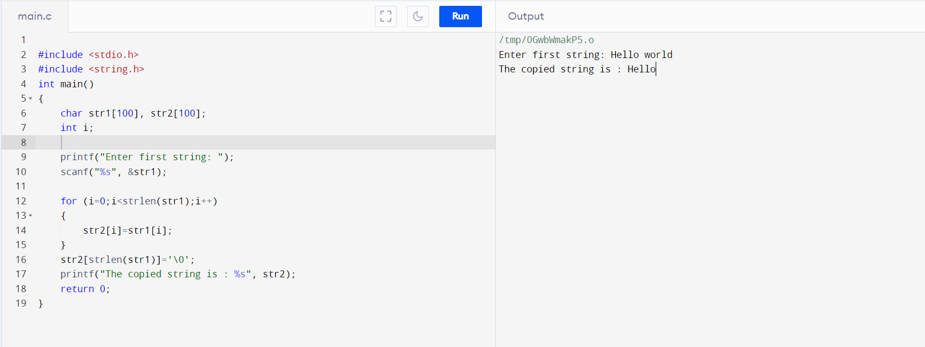Output: